Colin Morris-Moncada

Software Engineering

Professor Han

Exercise 3G.12 Triangle

Screenshot 1

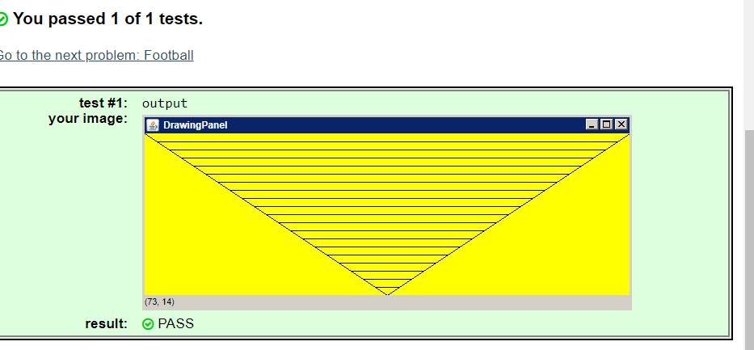

Screenshot 2 (next page)

